22.15: a)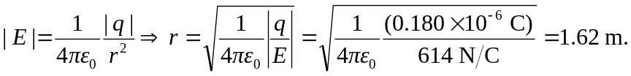
b) As long as we are outside the sphere, the charge enclosed is constant and the sphere acts like a point charge.

